17 Signs That You'd Qualify as a Witch in 1692
Leah Beckmann
IMAGE CREDIT:
Discover whether you are guilty of maleficium and/or would have been accused of practicing witchcraft according to the laws and evidence used during the 1692 Salem Witch Trials.

- YOU ARE FEMALE
Are you a woman of any kind? If so, you are probably one of the devil’s many hellbrides. Since the medieval period, “an aspect of the female has been associated with the witch.” For thousands of years, people have believed women to be more susceptible to sins than men, and sinning is a clear indication of devil worship. In Salem, 13 women and five men were convicted of practicing witchcraft, though historically the numbers dramatically favor accused women over men.

2. YOU ARE POOR/CANNOT SUPPORT YOURSELF FINANCIALLY
The poor, homeless, and those forced to rely on the community for support were among the most vulnerable and often accused of witchcraft. Sarah Good, hanged in 1692, was extremely disliked and distrusted by neighbors because she wandered from house to house begging for food.

3. YOU ARE RICH/FINANCIALLY INDEPENDENT
If you’re a grown woman living this life without any additional support, you probably also have a jar of eye of newt in your pantry. Any indication that a woman could live without the help or supervision of a man raised alarm. She would likely have been isolated from the community—until, of course, she was arrested and put on trial. Between 1620 and 1725, women without brothers or sons to share their inheritance comprised 89 percent of the women executed for witchcraft in New England.

4. YOU HAVE ONE OR MORE FEMALE FRIENDS
A note to all popular teens and the cast of Sex and the City: A group of women congregating without a male chaperone was deemed a “coven meeting to worship the Devil.” Ladies be communing with flirty cosmos and the devil.

5. YOU HAVE HAD AN ARGUMENT WITH ONE OR MORE OF YOUR FEMALE FRIENDS
Infamous witchfinders like Matthew Hopkins and John Searne inspired such terror in the community that it didn’t take long for women to accuse other women of witchcraft as a way of deflecting their own indictments. According to author Elizabeth Reis, “women were more likely than men to be convinced of this complicity with the devil, and given such convictions about themselves, they could more easily imagine that other women were equally damned.”
Take the case of Rachel Clinton: “Women of worth and quality accused [her] of hunching them with her elbow” when she walked by them at church. Rachel, herself a former woman of “worth and quality,” had a mentally disturbed mother and a late-in-life marriage that caused her to slip to the bottom rung of the class system. Add to that some finger-wagging biddies screaming about an elbow jab and, double double toil and trouble, Rebecca was convicted of witchcraft.

6. YOU HAVE HAD AN ARGUMENT OR DISAGREEMENT WITH SOMEONE
The important thing to remember is that anyone could accuse anyone. And they did. If you found yourself accused of practicing witchcraft of any kind by any kind of person, you might as well have been seen flying naked over the moon on a broomstick made out of a cursed lover’s ears.

7. YOU ARE VERY OLD
Older women, both married and unmarried, were extremely susceptible to accusations. Rebecca Nurse was a 70-year-old invalid when she was accused by disputing neighbors. At 71, she became the oldest woman tried, convicted, and put to death for being a witch.

8. YOU ARE VERY YOUNG
Dorothy Goode was only 4 years old when she confessed to being a witch (simultaneously implicating her mother, Sarah, who was hanged in 1692). Dorothy was imprisoned for nine months before her release. The experience left her permanently insane.

9. YOU ARE A MIDWIFE
Put simply by writer Joel Southern, a midwife’s “age, social and marital status, autonomy, pagan influences, secret knowledge of herbs and most importantly, the vilification of her profession as unclean and demeaning served to demonize the midwife. In short, the midwife represented everything the Church feared.”

10. YOU ARE MARRIED WITH TOO MANY CHILDREN
You have an unnaturally fertile womb that can only be the result of a dark magic. Add to that a young couple nearby having a difficult time conceiving, and you are almost certainly stealing would-be babies from them. Because you are a witch.

11. YOU ARE MARRIED WITH TOO FEW (OR NO) CHILDREN
The devil cursed your unholy womb with infertility. Plus, if your neighbors and their six children are suffering in any way, they almost certainly believe the jealous crone living next to them has hexed their home.

12. YOU HAVE EXHIBITED “STUBBORN,” “STRANGE,” OR “FORWARD BEHAVIOR"
Let loose any kind of sass or backtalk and ye be a witch, probably. Again, in the trial of Rachel Clinton, her accusers solidified the case against her with the following: “Did she not show the character of an embittered, meddlesome, demanding woman—perhaps in short, the character of a witch? Did she not scold, rail, threaten and fight?”

13. YOU HAVE A MOLE, BIRTHMARK, OR THIRD NIPPLE
Any of these found on the body could be interpreted as the Devil’s mark. This is also where the witch’s familiar—usually a dog, cat, or snake—would attach itself to her to drink her blood. The accused were completely rid of their body hair until some kind of marking was found. Now imagine a tiny puppy guzzling from Marilyn Monroe’s beauty mark.

14. BUTTER OR MILK HAS SPOILED IN YOUR FRIDGE
Several testimonials during the Salem Trials mention spoiled dairy products in connection with the accused. Be honest about the condition of your fridge before you continue.

15. YOU HAVE HAD SEX OUT OF WEDLOCK
Throw yourself directly into a blue hellfire if this one applies to you. In 1651, Alice Lake of Dorchester was tried as a witch for having “played the harlot, and being with Child.” Her guilt was so intense that she eventually confessed to convening with the devil “through the commission of her sin.” She was hanged that same year.

16. YOU HAVE ATTEMPTED TO PREDICT THE IDENTITY OF YOUR FUTURE HUSBAND
Ever daydreamed about your soulmate? Written his name in cursive in your notebook? Then, like Tituba, a slave woman living in Salem, your activities could be construed as witchcraft. Tituba encouraged young girls to predict the identities of their future husbands and became the first woman in Salem accused of practicing the craft. And thanks to dreamy succubi like you, she won’t be the last.

17. YOU HAVE BROKEN VIRTUALLY ANY RULE IN THE BIBLE AND THUS ENTERED INTO A PACT WITH THE DEVIL
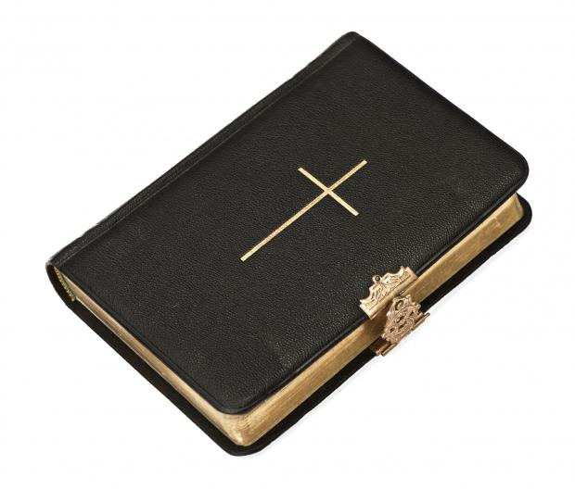
Here are a handful of rules the Puritans observed. Breaking any could lead to a witchcraft accusation:
-The strict observance of Sabbath, "the training day of military discipline.” This includes no fire, no trading, no traveling, and something called “new showbread In the holy place.” That last one is punishable by death.
-No adultery
-No leading people to other Gods by prophecy or dreams
-No getting raped
-No planting more than one type of seed in a field
-No touching a pig carcass
-No wearing clothing made of more than one kind of cloth or fabric
-No round haircuts
-No braided hair
-And definitely no suffering a witch to live

Did you do any of these things? Then congratulations, you are guilty of practicing witchcraft. You are hellbound, and will likely be hanged, burned, or left to rot in a filthy prison until you die. May the dark shadows cloak you in their wretched embrace. Hail Satan.
All images courtesy of Thinkstock unless otherwise noted.

