Device Distribution & Netiquette
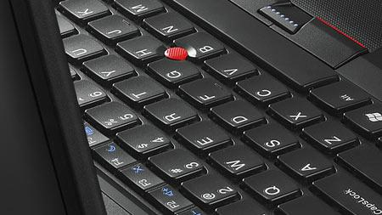
Objectives
- Receive new Chromebook
- Login to Chromebook
- Appropriate use
- Cyberbullying
- Digital footprint

Prep ~ Teacher to do ahead of time
There shouldn’t be any prep necessary for this class except for making sure you have a device for every student.

Chromebook Rollout Lesson Plan:
Distribution & Netiquette

Logging In
Have students login to their Chromebooks. DO NOT have students log in as guests.

- For students that CANNOT log onto their Chromebook for whatever reasons, please send them and their Chromebook TO THE NEAREST TECHNOLOGY COACH. There will be tech support on hand to ensure that ALL students are able to get into their devices.
  - Tech. Department ~ Media Center
  - Technology support (Tables setup in each hallway)
RHS: RETC:
Mariah Touchette - 600s and 900s Jason Frieling - Media Center
Tom Anderson - 500s and 600s
Danielle Roeser - 100s
Carrie Brunner - 300s and 400s
Julie Hopp - 200s
Tech. Kids - 700s

DO NOT have students log in as guests, as this will cause their chromebooks to need to be reset by the tech department. If they have trouble, send them to the nearest tech coach.

- Show students the video “The Top 10 Ways to Stay Out of Trouble With Your Chromebook”. This will last 5:36 minutes.

- What is netiquette?
  - Netiquette is basically your (Inter)net etiquette, or behavior.
  - Review infographic on last page (or click on link) and discuss proper behavior.

- Cyberbullying

Discuss Cyberbullying: What is it? What does it look like? How can I prevent it?

Have students go to goo.gl/ixL4xm

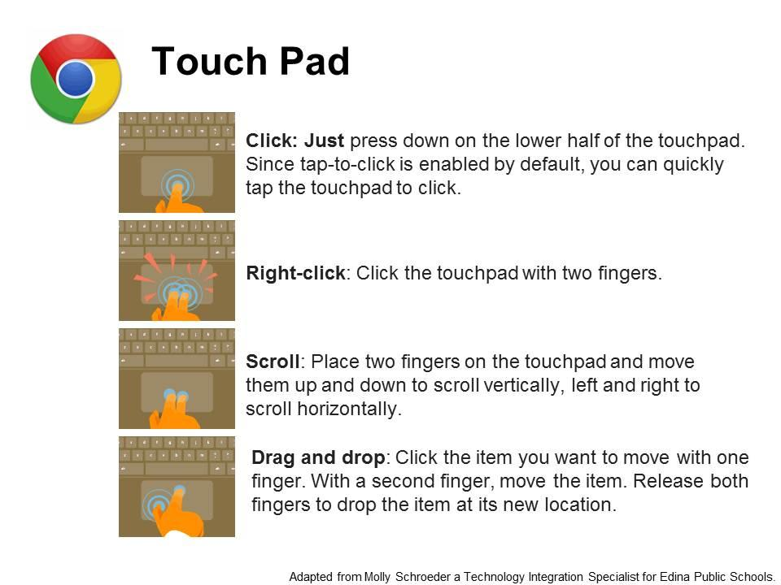
Scroll slowly with 2 fingers on the touch pad and read for this activity.

Periodically, you will encounter a point where you will need to choose one of two responses for the activity to continue. The touchpad works like a mouse, the left button is like left-clicking and the right button is like right-clicking.

Class Discussion

What were some of the inappropriate behaviors?

What role did all of the people involve play?

If you were that person who had their picture spread around, how would you feel?

If you wanted to use an app like this, what would you need to do before sending out a picture of someone?

- Digital Footprint
  - Show Digital Privacy video (2 min.)
  - Have students work in small groups to discuss what they want their digital footprint to look like.

If you want to see how this looked in a classroom, click here.
