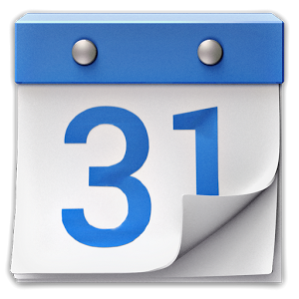
Bookmarks, Settings, Gmail, & Calendar
Objectives
- Creating bookmarks
- Customizing your apps in your Launcher
- Introduction to Gmail basics
- Introduction to Calendar basics

Prep - Teacher to do ahead of time
Just run through each little part so you know what to do.

Chromebook Rollout Lesson Plan:
Bookmarks, Settings, Gmail & Calendar

Getting to know your Chromebook
  - Family Guy Video
  - Ports and Parts
  - Keyboard keys
  - Keyboard shortcuts
  - Can hold a charge up to 8.5 hours, if charged completely
  - How to Conserve power (settings are found on lower-right corner of the screen)
    - Turn the screen brightness down as low as it can go, while still being useful.
    - Turn off Bluetooth.
    - Turn off your Chromebook when you’re not using it, instead of just shutting the lid. (Hold power button for four seconds)
  - Saving to the Cloud vs. local file storage

- Bookmarks
- This video clip will take you through the steps to bookmark sites that you use frequently.
- Watch the video on bookmarking with a chromebook. http://www.youtube.com/watch?v=1OxZ49D_5u4
- Send students to Parent Portal and bookmark
  - Type the address in https://ps.romeo.misd.net/public/home.html
OR
  - Go to RCS website (http://www.romeo.k12.mi.us/) and click
OR
  - class websites or textbooks
- ALTERNATIVE: Screenshot format
(older version of chrome, wrench instead of settings bar) http://www.googlechrometutorial.com/google-chrome-general-settings/Google-chrome-bookmarks-or-favorites.html#SavingBookmarksorFavoritesinGoogleChrome

- Launcher
  - Watch this short video to learn about the Launcher at the bottom of your screen. https://www.youtube.com/watch?feature=player_embedded&v=AQeHj5phuss

- Gmail
  - Who can you email?
    - Only those within the romeo.k12.mi.us domain.
  - Reply vs. reply to all
  - Conversation view
  - Delete vs. Archive
    - Archive removes the message from your Inbox but keeps it in your account so that you can find it later.
    - Delete moves the message to the Trash where it will be permanently deleted from your account after 30 days. Messages deleted from Trash can’t be recovered.
    - Gmail gives you plenty of storage space, so if you think there’s a chance you’ll need the message later, just archive it.

- Calendar
If you haven’t used the Google Calendar yet, you will find this tool very valuable to help you keep track of due dates, test dates, etc.
- Watch this video on creating an event in Google calendar http://www.youtube.com/watch?v=TYNjKfXwTvk&noredirect=1
- Create an event for charging your chromebook tonight in your calendar.
  - Open your calendar in Google Chromebook.
  - Get in “Week” view by clicking on Week 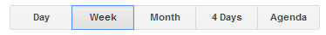
  - click
  - Type ‘Charge Chromebook’ in the box and fill in the following times.
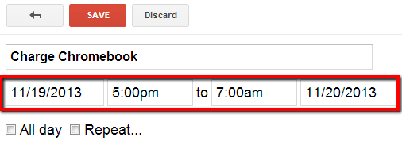
  - Click ‘Save’

