Google Drive

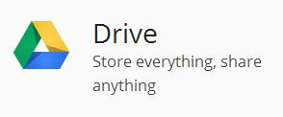
Objectives
- Access Google Drive
- Create documents and folders
- Learn about sharing settings
- Manage your documents in Drive

Prep ~ Teacher to do ahead of time = none

Chromebook Rollout Lesson Plan:
Google Drive

What is Google Drive? (5-10 Min)
  - Introduction - What is Google Drive? video
  - 30 Rock Example

Creating Docs & Folders (10 min)
- Introduction - How do I create in Drive? video (approx. 2 min.)
- Show students the icon for google drive in the “Launcher “ (taskbar at bottom)
- Creating a document
  - Click the red CREATE button
  - Students can practice creating a doc, spreadsheets or slides if they want to
  - If you are familiar with docs, consider showing them some of your favorite features

- Activity - Make a folder for each class
  - Click the red CREATE button
  - Choose FOLDER
  - Name the folder: 1 + Course Name (ex: 1 Geometry)
  - Create a folder for each hour: 2, 3, 4, 5, etc
  - If you need to rename the folders:
    - Right Click on the number, choose Rename from the quick-menu that appears
OR
    - Place a check mark next to the folder, click the More tab, choose Rename

Sharing (10 min)
- Introduction - How do I share in Google Drive? video (approx. 4 min)
- Sharing docs
  - Talk about the differences in sharing options (Share ---> Change)
    - Public on the Web = Never, ever use; opens your docs up to hackers
    - Anyone with the Link = ???
    - Romeo Community Schools = Any at RCS can try to locate your docs
    - Anyone at Romeo Community Schools with link = you can copy and paste this link to anywhere without having to “Share” it with them
    - Private = the default setting for docs
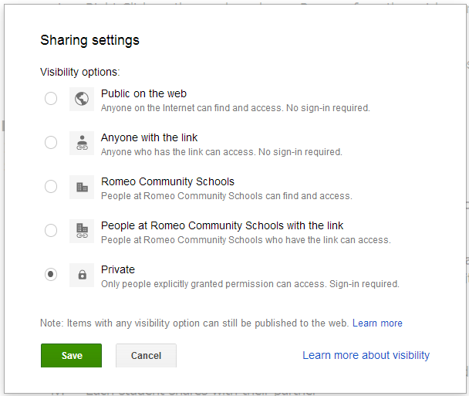

  - Some sharing basics
    - Click the blue share button
    - Enter your partner(s) gmail address in the bottom of share window
    - Uncheck Notify by email if they are sitting right next to you
    - Go back to your Drive
    - Locate your “Shared with Me” section...That is where you can find it.
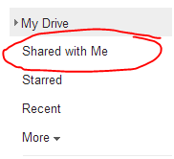
- Managing your docs
  - Managing Your Docs video (approx. 4 min)
  - Docs navigator is located in the left-hand sidebar menu
  - Folder organization - can put folders in folders
  - Shared with Me is “Inbox” for docs you don’t own
    - Can drag docs from “Shared with Me” --> Drive for organization
  - Move shared doc to “My Drive” folder for that class period

If you want to see how this looked in a classroom, click here.

