Name: ________________________________________________ Hour: __________ A.O.W. #8
The Chicago Tribune
July 23, 2013|By Rex W. Huppke

Saying racism is over is the new saying you have 'a black friend'

Huppke: Dear black people: If white people say racism doesn't exist, turn to me, your 'white friend'
  - 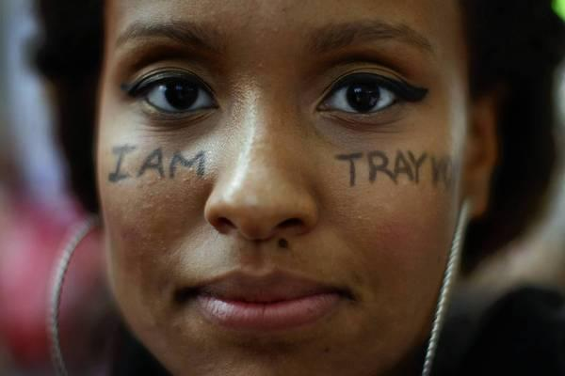
A message on a Los Angeles protester’s face Saturday displays her support for Trayvon Martin, who was shot and killed by George Zimmerman last year. (DAVID MCNEW, Reuters Photo)

I'm getting a little worried about white people.
Since a Florida jury found George Zimmerman not guilty in the shooting death of Trayvon Martin, a surprising number of Caucasians have taken it upon themselves to let black people know that racism no longer exists.
Although one would technically think this is good news, it has been received with considerable harrumphing, probably because: A) It's not true; and B) If it were true, it doesn't seem fair, given the history of things, that white people would be the first ones to know.
Still, declarations that America is virtually racism-free came flying in the days after the Zimmerman verdict.
On his blog on Forbes.com, Peter Ferrara of the Heartland Institute, a Chicago-based conservative think tank, wrote: "People who believe the Progressive storyline that America is a racist society believe it because they want to believe it, even though racist attitudes, now reserved to the lower classes and uneducated, no longer have any power or influence in American society."
John Nolte ‏of the conservative website breitbart.com wrote on Twitter: "I like living in a country where a black president elected twice complains about racism."
And noted white people expert, rock 'n' roll star and high-capacity firearm enthusiast Ted Nugent said in a radio interview: "(R)acism against blacks was gone by the time I started touring the nation in the late '60s."
I'm not one to doubt the Motor City Madman's historical knowledge, but he seems to overlook a few things that happened after the late '60s:
•The Tuskegee syphilis experiment, which didn't end until 1972 and which the government didn't formally apologize for until 1997.
•The Nov. 7, 1984, attack on a black family's apartment on the West Side of Chicago near Cicero by about a dozen white men hurling bricks and bottles.
•The fact that no black governors were elected until 1990, when Douglas Wilder became governor of Virginia.
•The 1998 dragging death of James Byrd in Texas.
•A man photographed wearing a shirt at a 2012 Mitt Romney rally in Ohio that read "PUT THE WHITE BACK IN THE WHITE HOUSE."
Mr. Nugent also must have missed these recent comments from a white man: "Nothing of consequence existed to deter or compromise a black American's dream if they got an alarm clock, if they set it, if they took good care of themselves, they remained clean and sober, if they spoke clearly, and they demanded excellence of themselves."
According to a Google search and my ears, the person who said that is one Theodore Anthony "Ted" Nugent. So yes, Mr. Nugent, racism clearly ended in the late 1960s and all this other stuff — including a number of comments that I'm guessing will be posted below the online version of this column — are just minor misunderstandings.
I feel it's important at this point to make a startling admission: I am white, and have been for most of my life. I believe racism still exists, both because I've witnessed it and because Ted Nugent is an actual person and not a fictional amalgamation of white stereotypes.
On Friday, President Barack Obama spoke about the Trayvon Martin case and tried to explain why — regardless of the specific facts brought up in court — many black people were angry about the verdict.
"I think it's important," the president said, "to recognize that the African-American community is looking at this issue through a set of experiences and a history that doesn't go away."
Some refused to believe those words. Shortly after Obama's comments, Fox News host Todd Starnes declared him "our Race-Baiter in Chief."
I don't understand why some of my fellow white people have become racism-deniers. Perhaps they hope to focus their energy on other things, like being the primary purchasers of rap music.
I think most rational people, white or black, can acknowledge, as Obama did in his comments, that things are better than they used to be, racism-wise. But we've still got work to do.
And I'd like to help.
A long-standing go-to move for racists has been to declare themselves nonracist by pointing out that they have "a black friend." Consider Keith Bardwell, a Louisiana justice of the peace who made news in 2010 for refusing to issue a marriage license to an interracial couple.
"I'm not a racist. I just don't believe in mixing the races that way," Bardwell told The Associated Press at the time. "I have piles and piles of black friends."
Well, now that there are white people saying racism is over, it seems logical that black people are going to need "a white friend" — specifically "a white friend who believes racism is not over."
I'd like to be that white friend.
If you're black and a white person says to you, "C'mon, there's no racism in America anymore," just say, "I disagree. And I have a white friend named Rex who also disagrees."
Case closed.
By taking advantage of my skin color and my unwillingness to accept that we live in a post-racial America, we can join together and drown out the noise of the Nugents and the knuckleheads.
Then, perhaps, we can focus on the racism that does still exist. And work toward a day when a person can say "racism is over," and not sound like a complete moron.
rhuppke@tribune.com

Article Summary:

