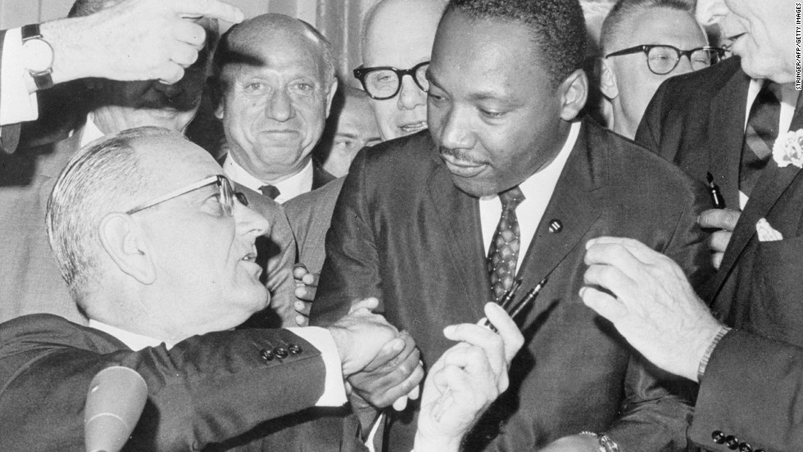

+LBJ shakes hands with civil rights leader Martin Luther King, Jr. after signing the Civil Rights Act of 1964.

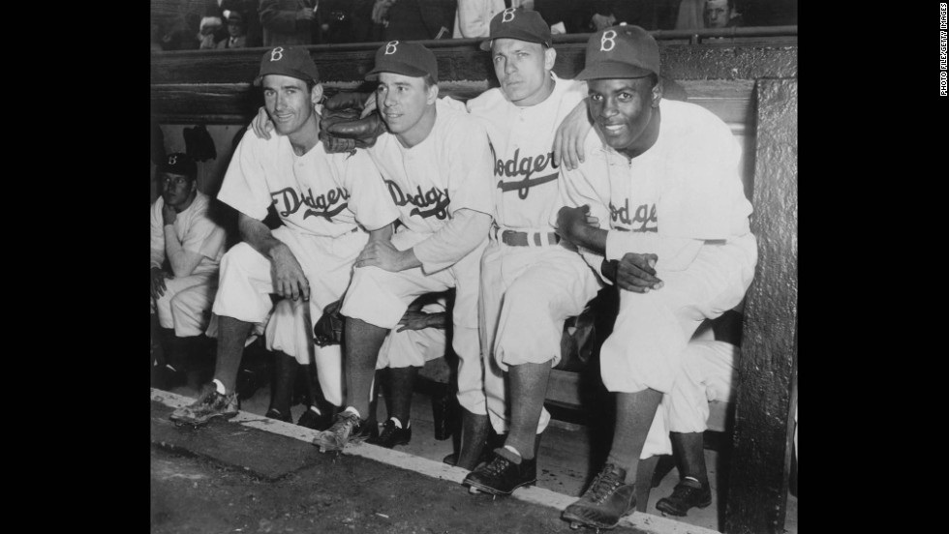

Jackie Robinson, who broke Major League Baseball’s color barrier, poses in the dugout with some of his Brooklyn Dodger teammates during his first game o April 15, 1947.

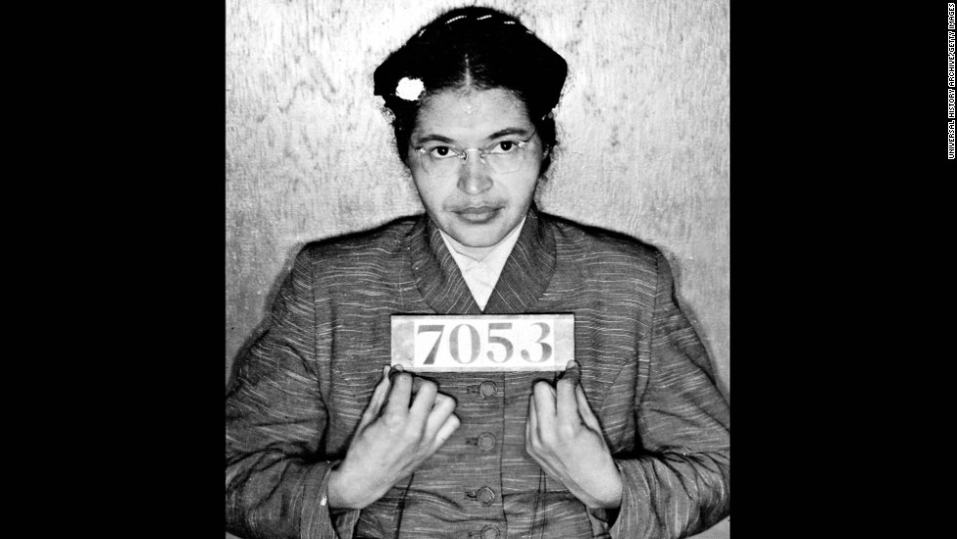

Rosa Parks poses for her booking photo after she was arrested in Montgomery, Alabama for refusing to give up her seat to a white passenger in 1955.

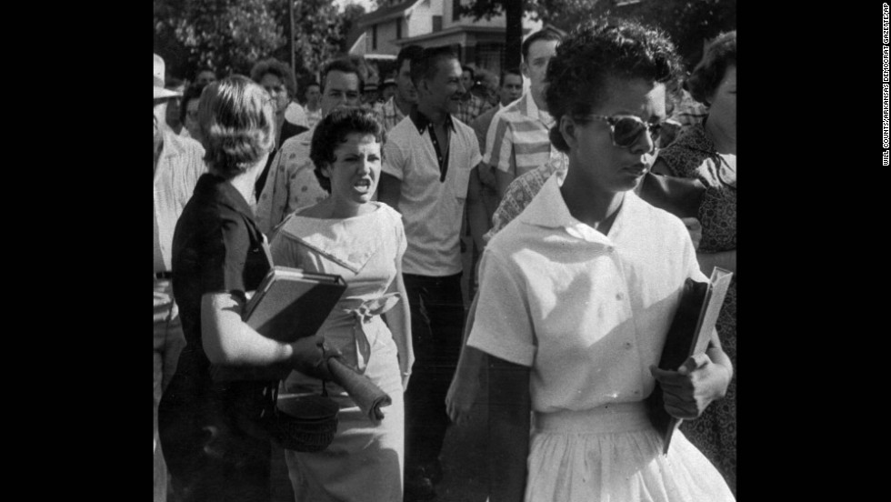

Students at Central High School I Little Rock, Arkansas, shout insults at Elizabeth Eckford as she walks toward the school building on the first day of school in 1957.

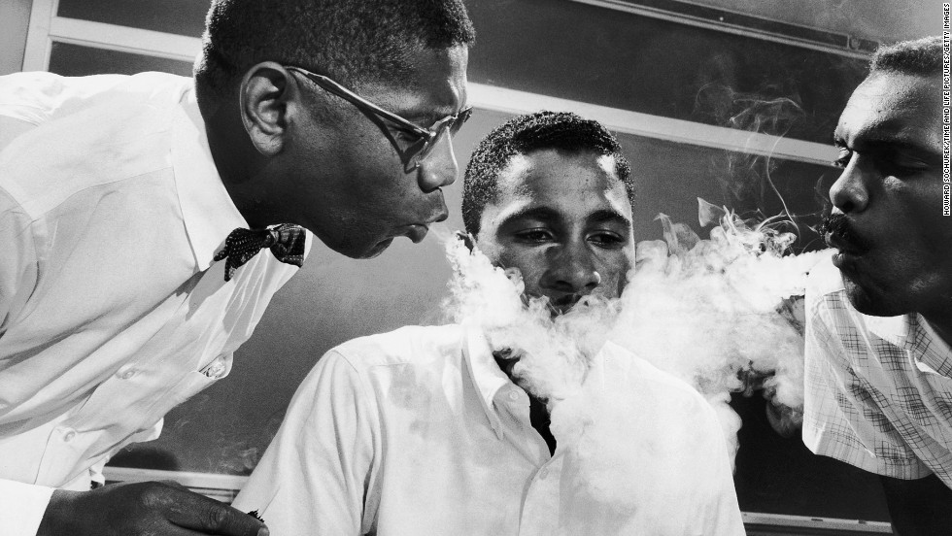

As part of his training for sit-in protests in 1960, student Virginius Thornton practices reacting to smoke being blown in is face.

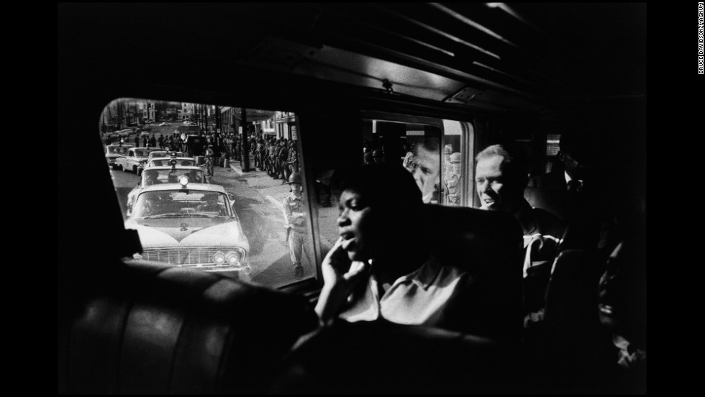

Freedom Riders sit on a bus during a trip from Montgomery to Jackson, Mississippi, in 1961. Freedom Riders would brave mobs and endure savage beatings to desegregate interstate travel.

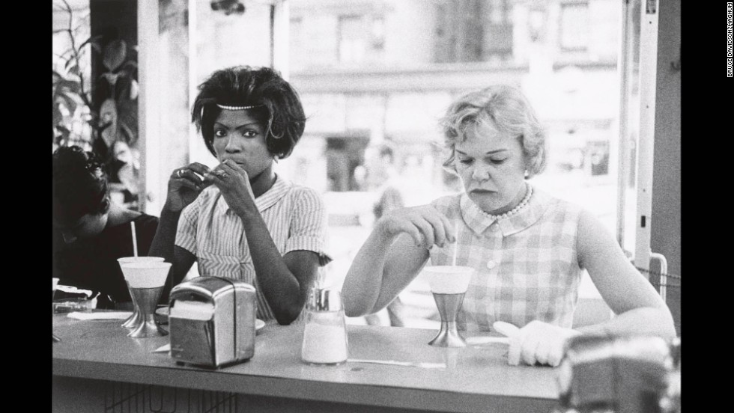

A black woman and white woman sit next to each other at the New York City restaurant in 1962.

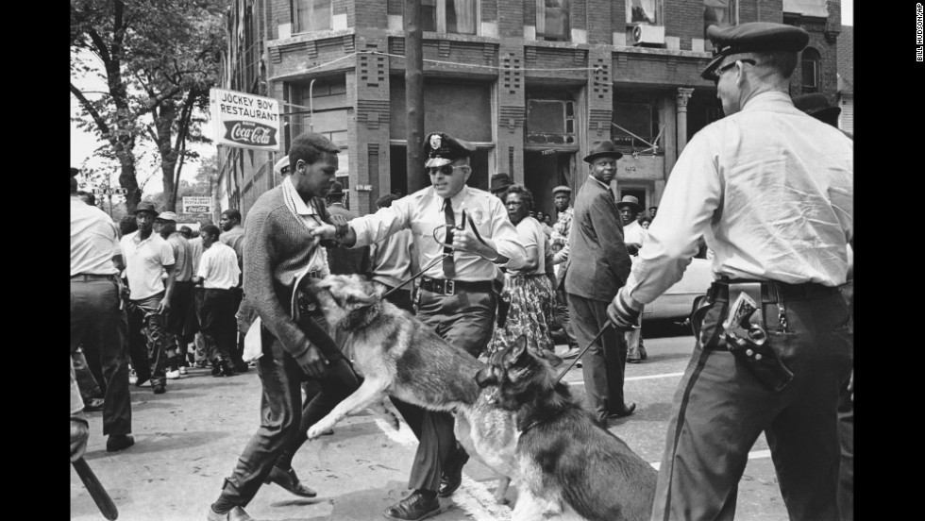

A police dog jumps at a 17-year old civil rights demonstrator in Birmingham, Alabama, on May 3, 1963.

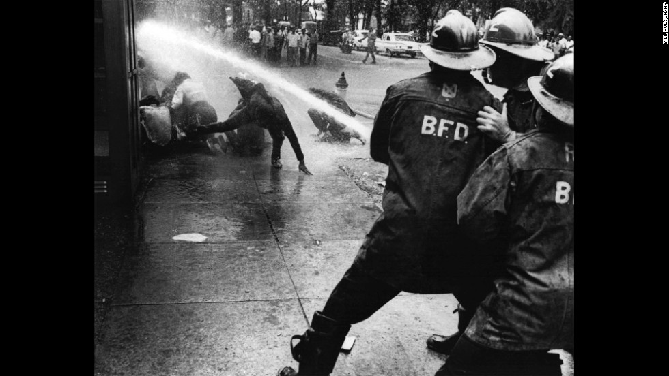

Firefighters turn their hoses on demonstrators in Birmingham in July 1963.

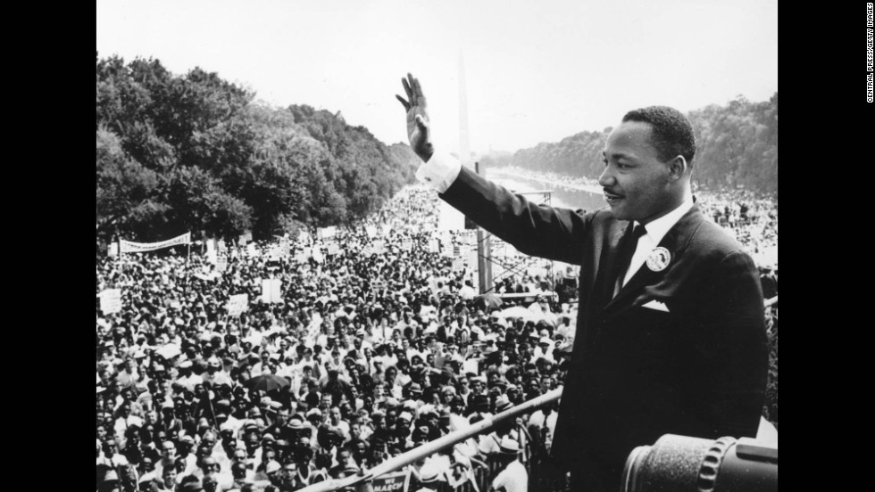

King addresses the crowd at the Lincoln Memorial in Washington, where he delivered his famous “I Have a Dream” Speech.

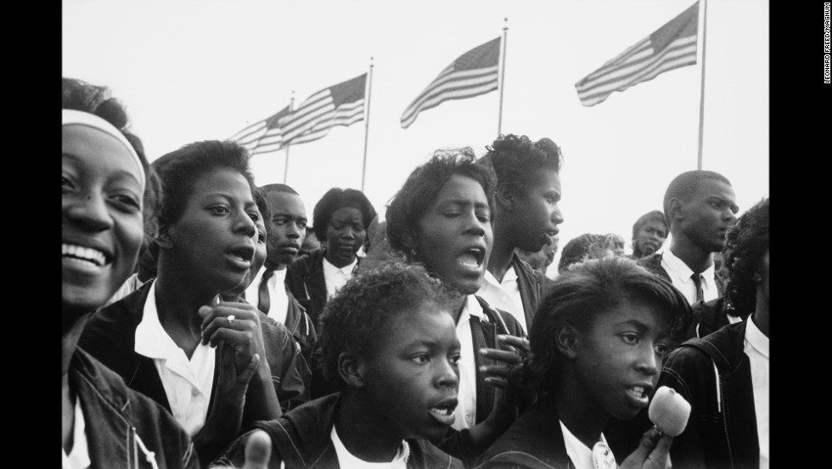

People gather on the National Mall during the March on Washington in 1963.

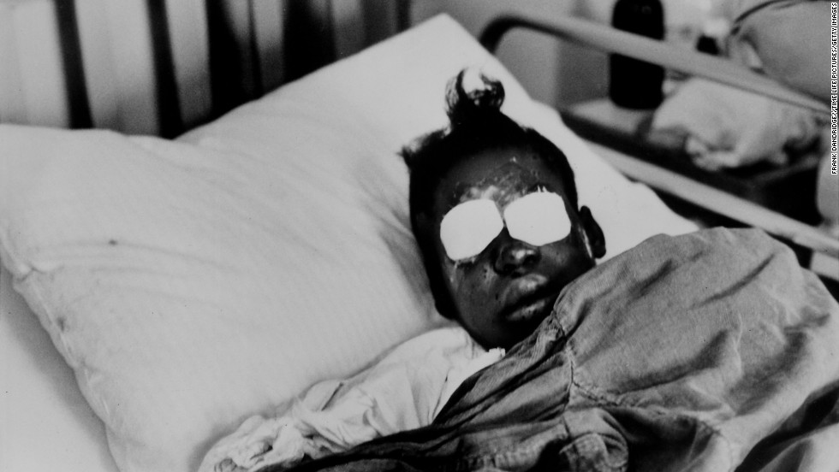

Sarah Jean Collins, 12, lies in bed after being blinded by the dynamite that killed her sister in the bombing of a Birmingham church in 1963.

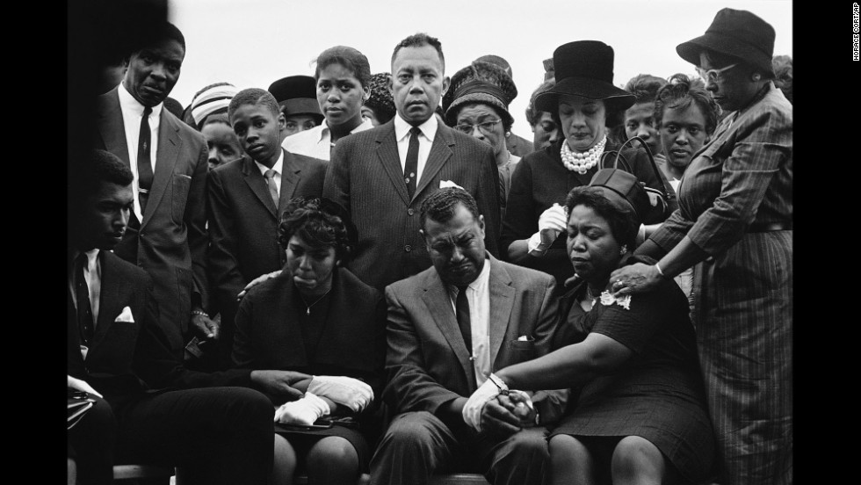

The family of Carol Robertson, a 14 year-old girl killed in the church bombing in Birmingham, 1963.

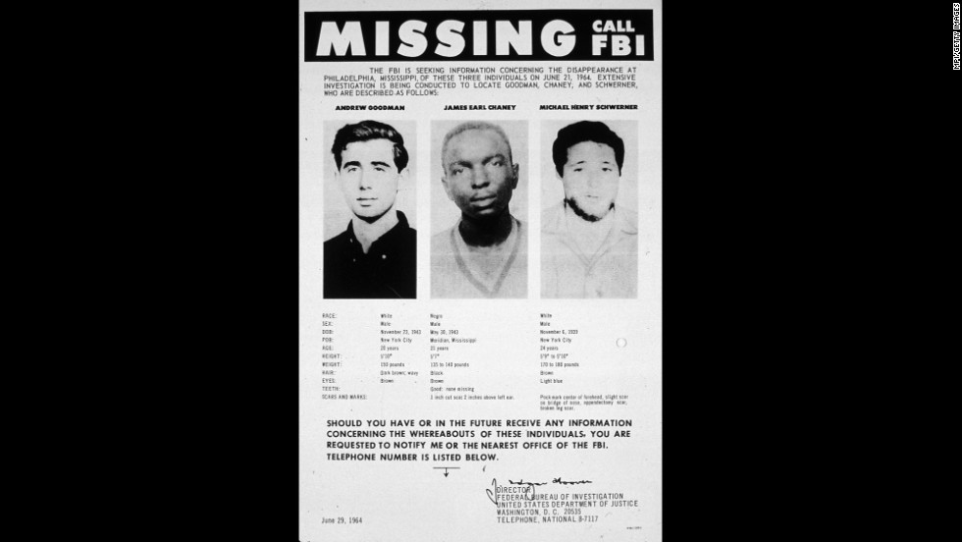

A 1964 FBI poster seeks information on the whereabouts of Goodman, Chaney, and Schwerner. The three civil rights workers disappeared I rural Mississippi in the summer of 1964. Their bodies were found 44 days later. They had been tortured and murdered

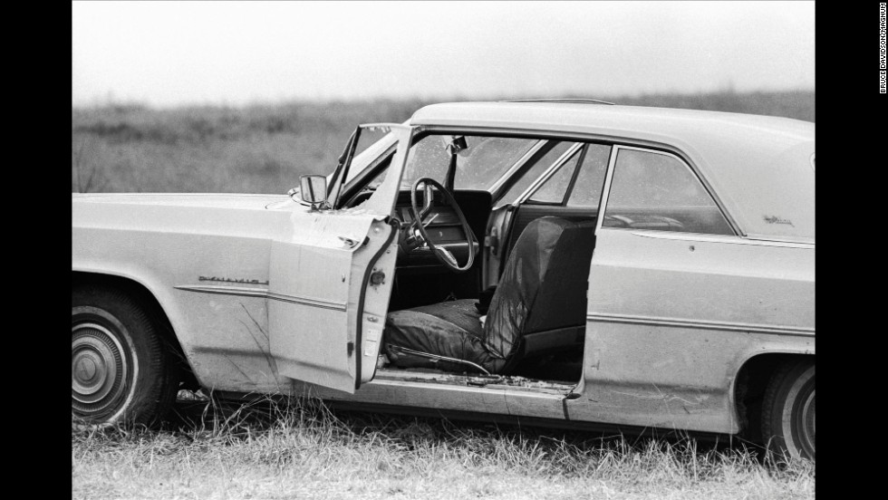

The car of Viola Liuzzo sits off the road near Selma, Ala. In 1965. Her car was run off the road and she was shot to death because she supported desegregate=ion.

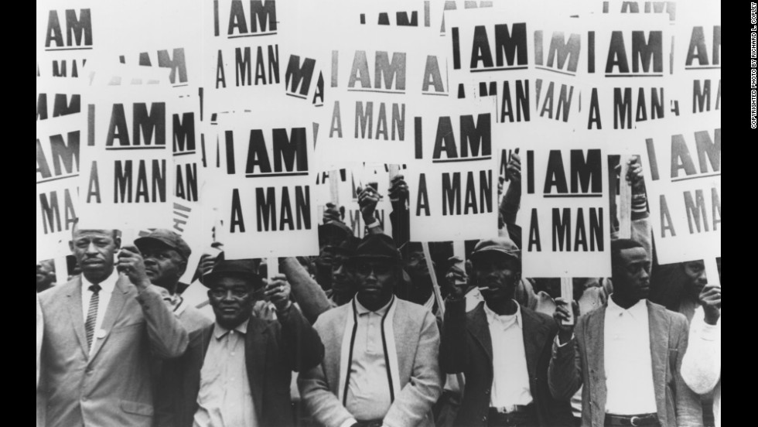

Memphis sanitation workers hold signs with the slogan “I am a Man” during a strike in 1968,

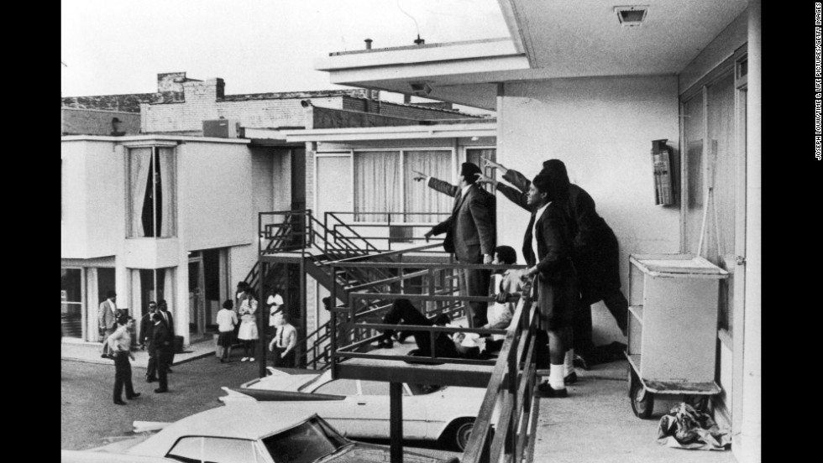

King lies bleeding at the feet of other civil rights leaders after he was shot on the balcony of the Lorraine Motel o Memphis, April 4, 1968

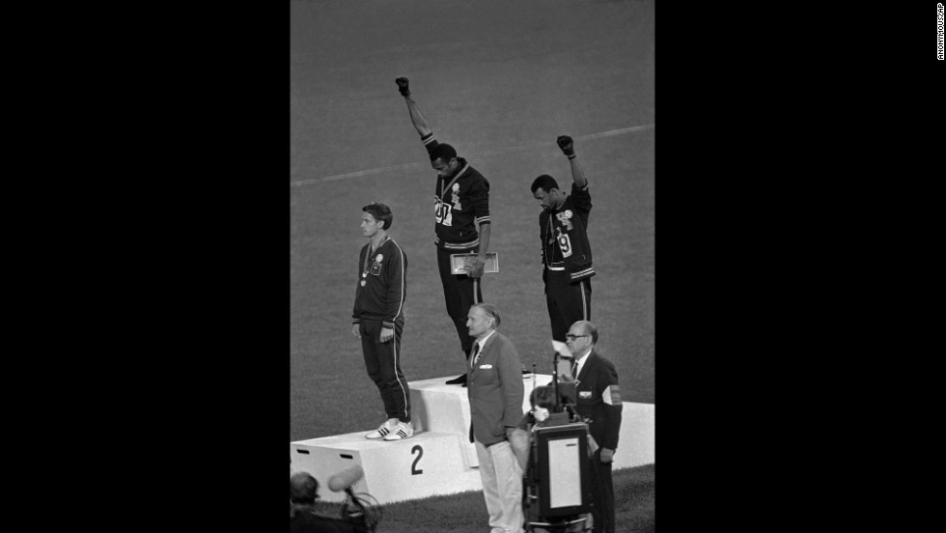

U.S. Olympians Smith, and Carlos raise their fists in protest during the U.S. national anthem, which was being played after Smith won the 200 meters at the 1968 Olympics.

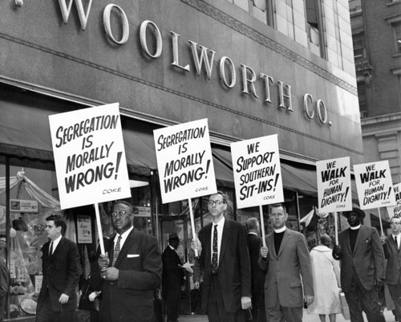

Demonstrators, including many ministers, picket in New York, 1960.

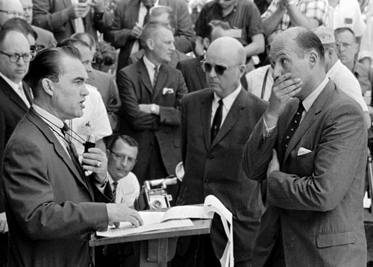

Gov. George Wallace prevents black students from reregistering at the Univ. of Ala. In 1963.

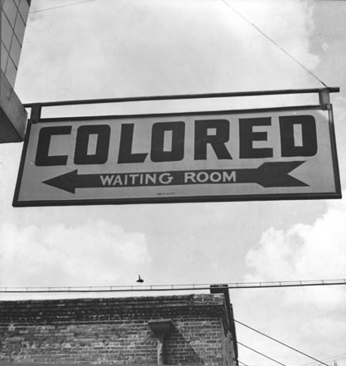

A sign at the Greyhound bus station, 1963.

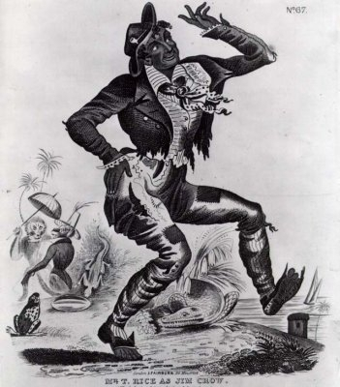

“Daddy” Rice, in blackface as Jim Crow.

