Senior Literature
Nicolia

Coat of Arms
Definition: the distinctive heraldic bearings or shield of a person, family, corporation, or country.

Examples:
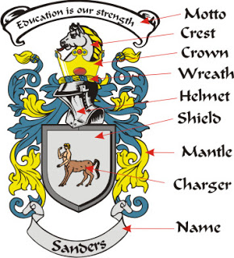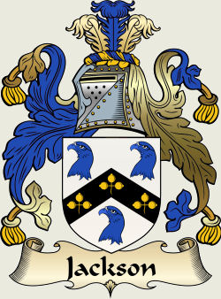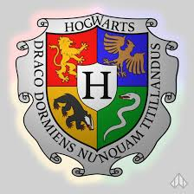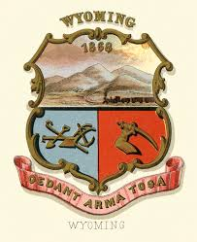

Objective: Design a Coat of Arms for one of the following characters: Beowulf, Grendal, King Arthur, Sir Gawain, The Green Knight, or Mr. Osborne

DIRECTIONS: (computer paper)
- On the front, draw the Coat of Arms, making sure to strategically utilize color.
- On the back of the paper, explain the choices you made and why you made them.
  - In other words, provide a justification of your choices for that particular character.

Assistance/Research: The following websites will provide you with some information about heraldry - symbols and colors you can use when designing the Coat of Arms.

- http://www.familytreesandcrests.com/heraldry-symbols.htm
- http://www.fleurdelis.com/meanings.htm
- http://www.genesreunited.co.uk/blog/genes-reunited-blog/archive/2013/11/7/what-the-symbols-on-coats-of-arms,-family-crests-and-seals-mean
- https://www.dallastown.net/cms/lib6/PA01000011/Centricity/Domain/219/Meaning%20of%20Colors%20and%20Symbols.pdf
- You can also Google Coats of Arms Templates and print out something to start from.
- Careful though. You still need to explain the elements of the Coat of Arms.

Extra Credit: Worth up to 20 points—New sheet of computer paper
- On the front, design a Coat of Arms for yourself
- On the back of the paper, explain the choices you made and why you made them.

