Raisin in the Sun – Film Viewing Guide Name: __________________________________

Character Connections:
Beneatha Younger

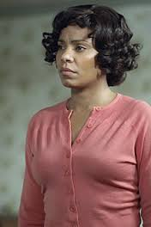
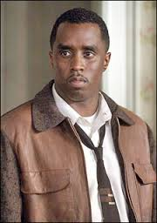

?
?

Lena Younger
“Mama”
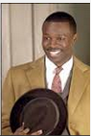
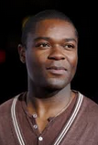
Walter Lee Younger
Ruth Younger

Asagai

George

Travis Younger

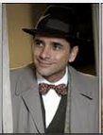
Bobo

Film Viewing Guide: Follow answering guidelines to earn full points. Answer more than requested will equal extra credit points. Quality matters!

Act I Scene One: Answer 4 of the 8 Questions-------------------------------------------

- Why did Walter ask Ruth what was wrong with her?

- Why was Ruth upset when Walter gave Travis the money?

- Who are Willy and Bobo?

- Walter said, "Damn my eggs . . . damn all the eggs that ever was!" Why?

Mr. Lindner

- Who is Beneatha?

- Why was Mama getting a check for $10,000?

- Why did Beneatha say she wouldn't marry George?

- What was Beneatha's attitude towards God?

Act I Scene Two: Answer 3 of the 7 Questions--------------------------------------------------------------

- Who is Joseph Asagai?

- What did Ruth find out at the doctor's office?

- Why is Asagai's present to Beneatha appropriate?

- Why is Asagai's nickname appropriate?

- What does Mama say is "dangerous"?

- Where did Ruth actually go instead of the doctor's office?

- Why did Mama call Walter a disgrace to his father's memory?

Act II Scene One: Answer 2 of the 4 Questions-------------------------------------------------------------

- What was Beneatha's family doing when George came in?

- What are "assimilationist Negroes"?

- What did Mama do with her money?

- What was Walter's reaction to Mama's purchase? Ruth's reaction?

Act II Scene Two: Answer 2 of the 3 Questions--------------------------------------------------------------

- How did Ruth find out Walter hadn't been going to work?

- What did Mama do for Walter?

Act II Scene Three: Answer 2 of the 4 Questions------------------------------------------------------------

- Who was Karl Lindner, and why did he visit the Youngers' house?

- What was Walter's reaction to Lindner?

- What presents did Mama get?

- What news did Bobo bring to Walter?

Act III: Answer 4 of the 7 Questions----------------------------------------------------------------------------

- Why didn't Beneatha want to be a doctor anymore?

- How did Asagai define "idealists" and "realists"?

- What does Asagai ask Beneatha to do?

- What fault does Mama find with herself?

- What solution does Walter have?

- Why didn't Walter take the money Lindner offered?

- Did the Youngers stay or move?

Interpretive: Answer 2 of the 5 Prompts-----------------------------------------------------------------------
- What does the setting add to the story?

- Describe the relationship between Ruth and Walter.

- Describe the relationship between Mama and Walter.

- Describe the relationship between Beneatha and Walter.

- What function does the character of Travis serve in the play?

Critical/Personal Response: Answer 1 of the 3 Prompts----------------------------------------------------
- Who is responsible for Walter's situation? Explain why.

- Why did the author include the element of Ruth's pregnancy? What did it add to the story?

- Who is the main character in the play? Justify your answer.

Personal Response: Answer 1 of the 3 Prompts--------------------------------------------------------------
- Is the story of A Raisin in the Sun believable? Explain why it is or isn't.

- Suppose Walter would tell a friend about the events of this play fifteen years from the day they moved into the new house. What do you think he would say?

- What do you think happened to the Youngers after they moved to Clybourne Park?

Quotations: Answer 2 of the 4 Prompts-----------------------------------------------------------------------
Explain the importance or significance of each of the following quotations.
- Baby, don't nothing happen for you in this world 'less you pay somebody off.

- Once upon a time freedom used to be life--now it's money . . . . .No--it was always money, Mama. We just didn't know about it.

- We all tied up in a race of people that don't know how to do nothing but moan, pray and have babies!

- Sometimes it hard to let the future begin.

