English
Research DSPA

Google Drive- DSPA Instructions

- Login to your Google Accounts & Go to your Google Drive

- Create a new folder
    - Click New, Select Folder
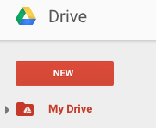

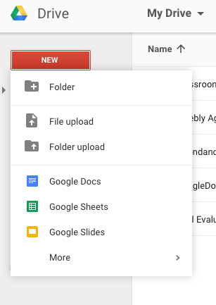

- Name it: “Research DSPA 2016”
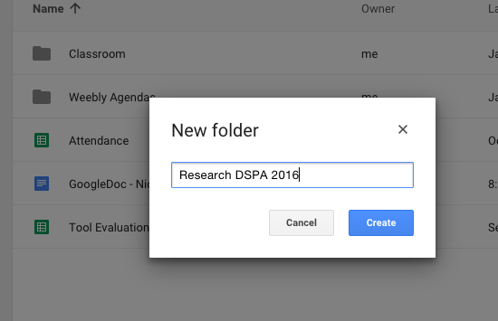

- Within the new folder
  - Create a New Google Doc
  - Click New, Select Google Doc

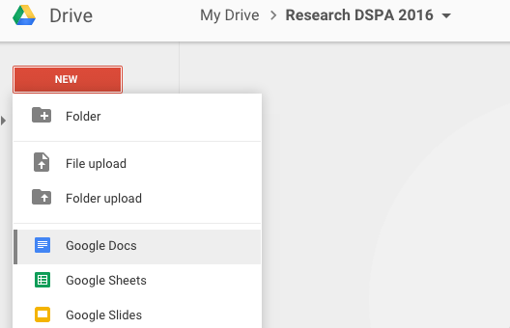
  - Name it: “DSPA Works Cited”

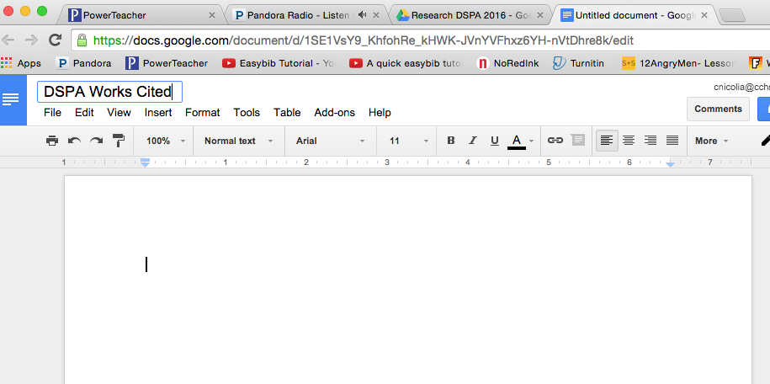

Double Check it is in your new folder
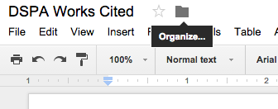

TURN OVER
Formatting Works Cited Page

Basic Rules:

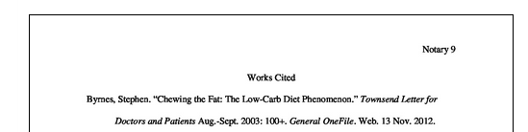
Placement: The Works Cited list appears at the end of the paper, on its own page(s). If your research paper ends on page 8, your Works Cited begins on page 9.
Works Cited is centered.
Do not underline, bold, or italicize.

The sources are right aligned.
Arrangement: Alphabetize entries by author's last name. If source has no named author, alphabetize by the title, ignoring A, An, or The.
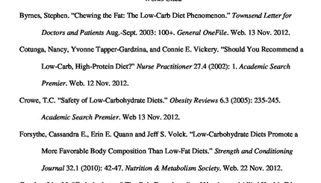

Spacing: Like the rest of the MLA paper, the Works Cited list is double-spaced throughout. Be sure NOT to add extra spaces between citations. (See image above).
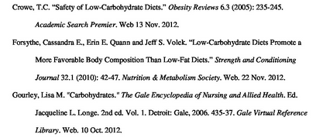
Indentation: To make citations easier to scan, add a hanging indent to any citation that runs more than one line.

