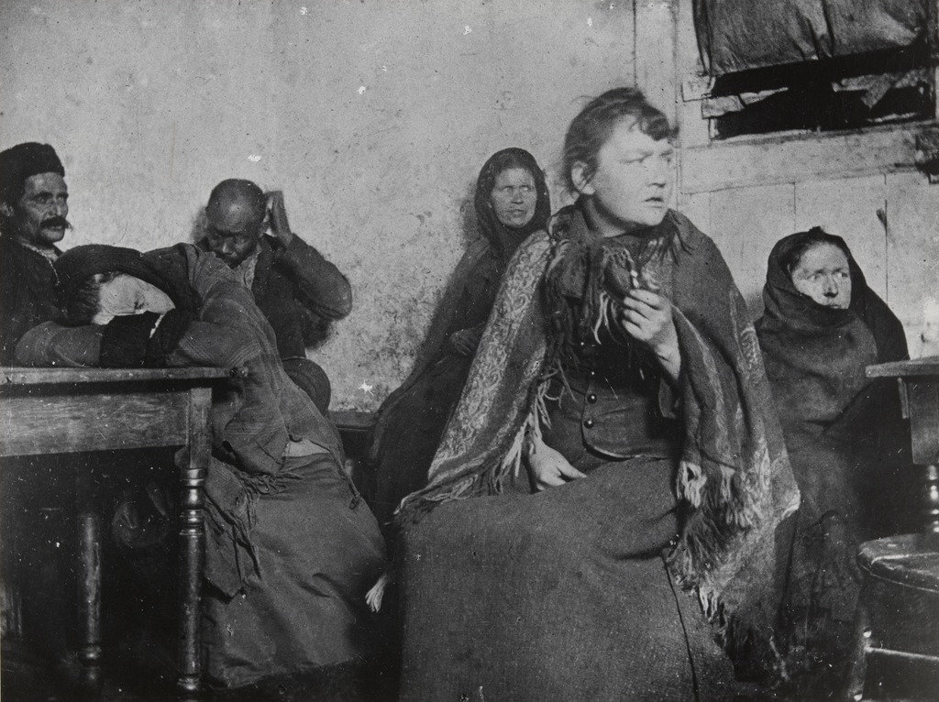
In a Dive (1895)

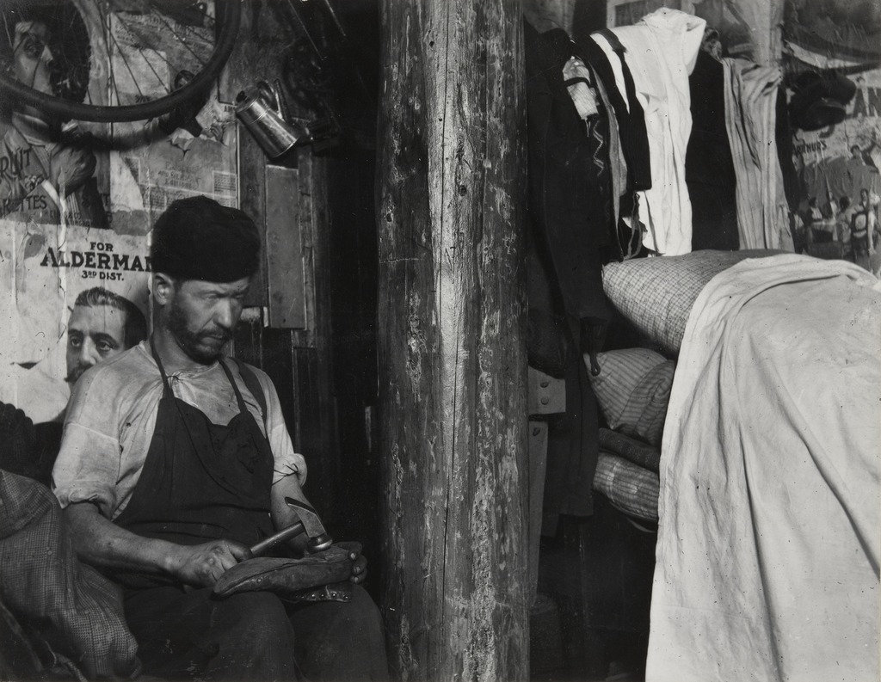
Shoemaker, Broome Street (1888-1895)
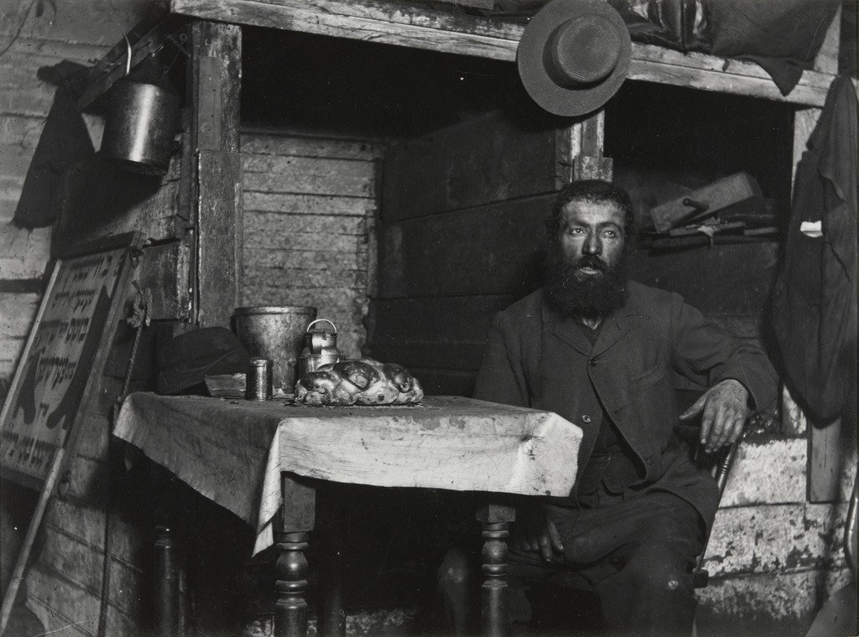
Sabbath Eve in a Coal Celler, Ludlow Street (1888-1895)

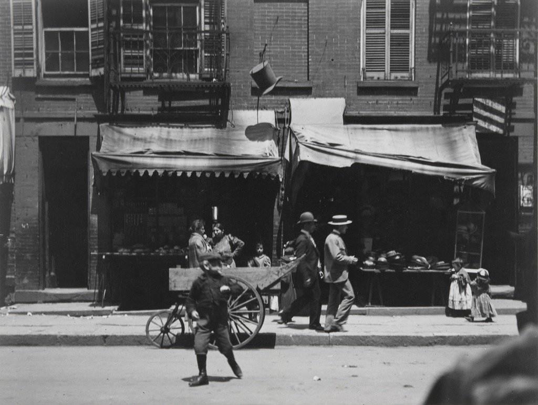
The Street, their Playground 1888-1895)

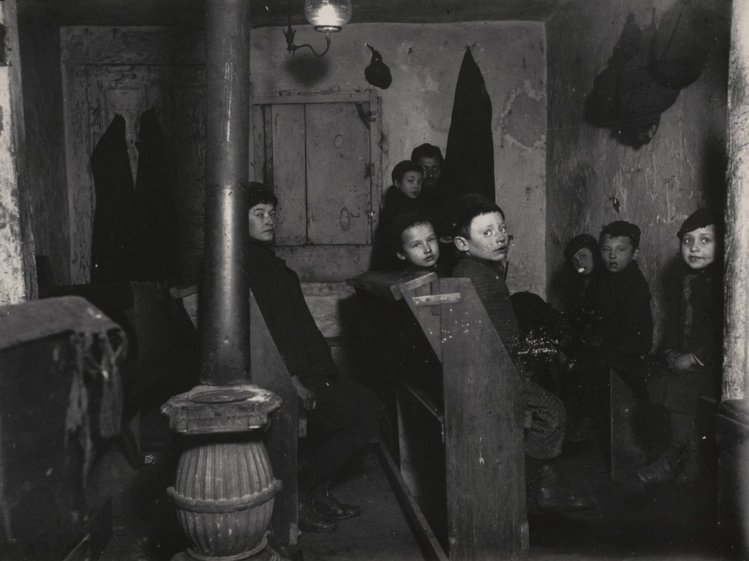
Talmud School in a Hester Street Tenement (1888-1895)
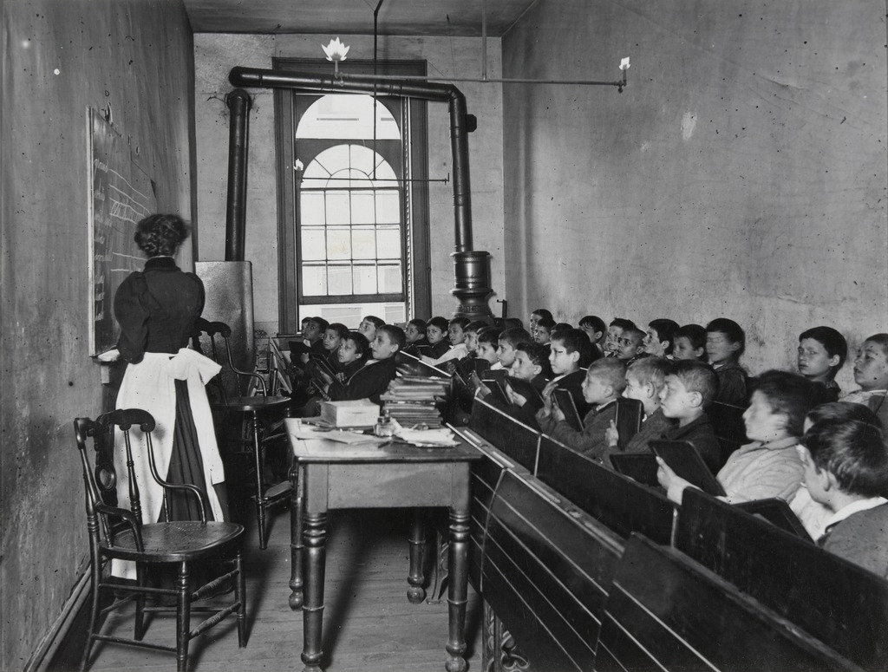
East Side Public School. (1888-1895)

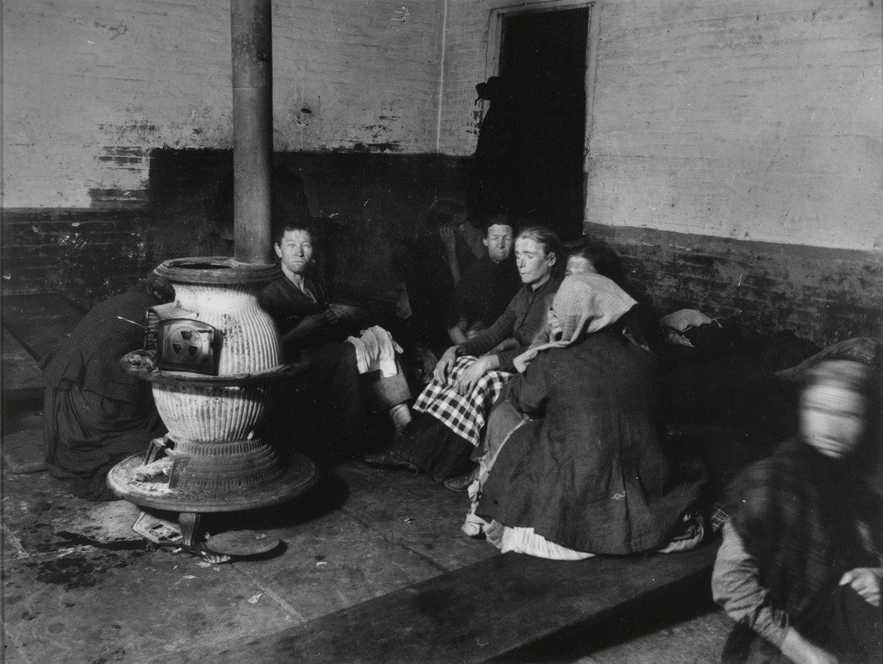
Police Station Lodgers in Elizabeth Street Station (1888-1895)

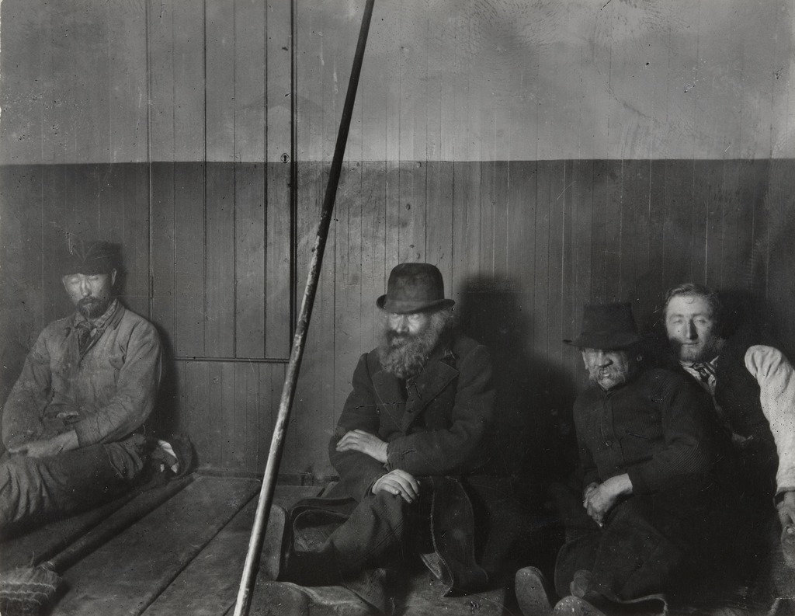
Police Station Lodgers in Oak Station (1890)
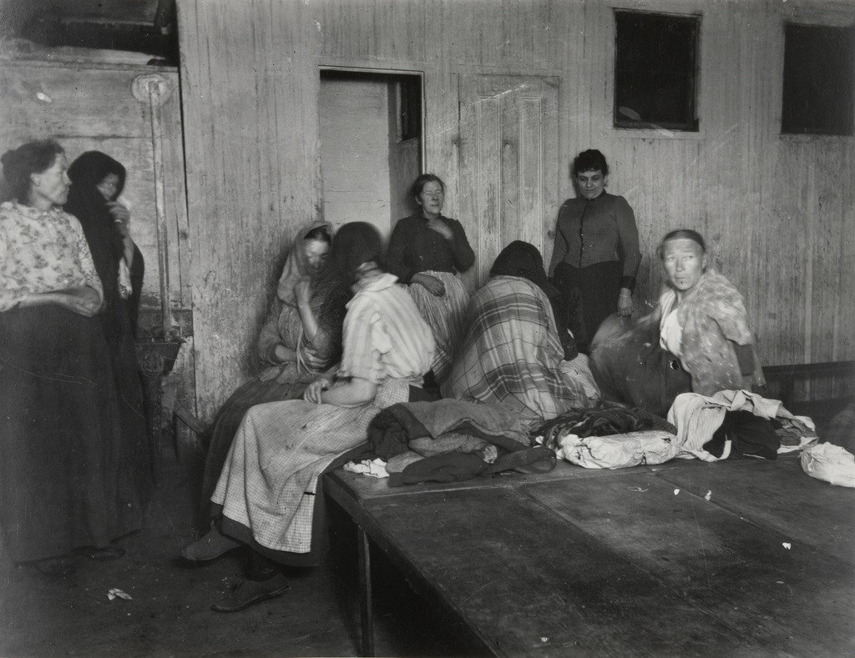
Women in Elizabeth Police Station (1890)
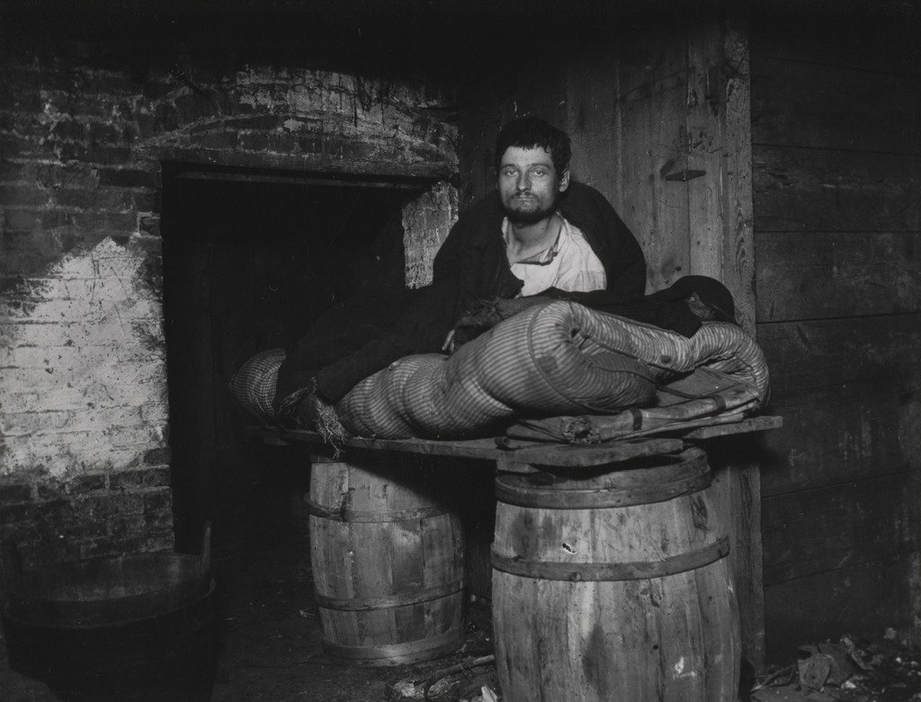
The Man Slept in This Cellar for Four Year (1890)
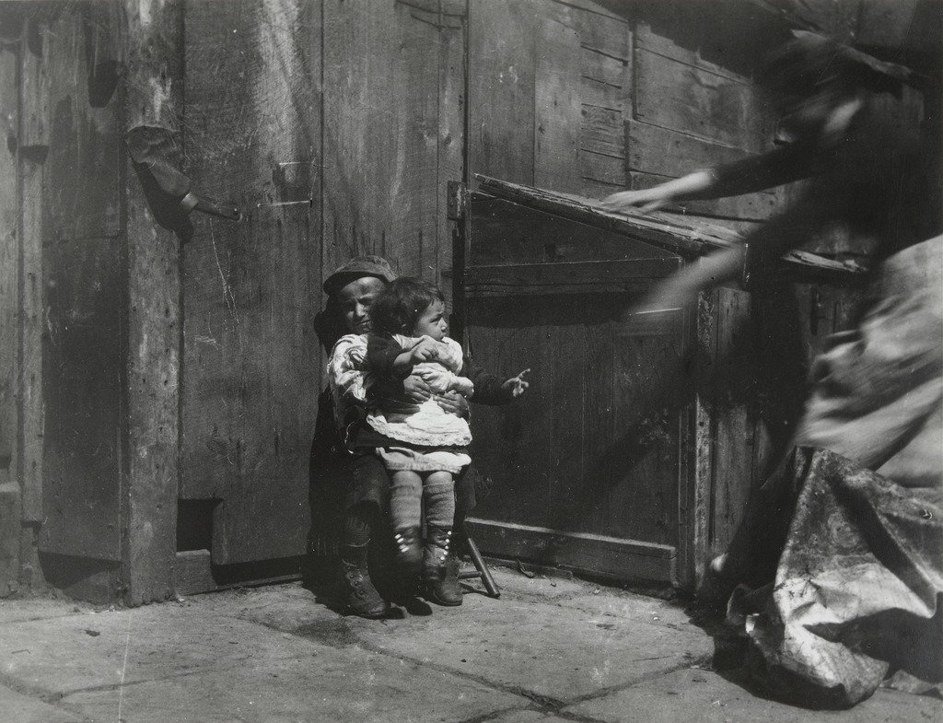
Minding the Baby. (1889)
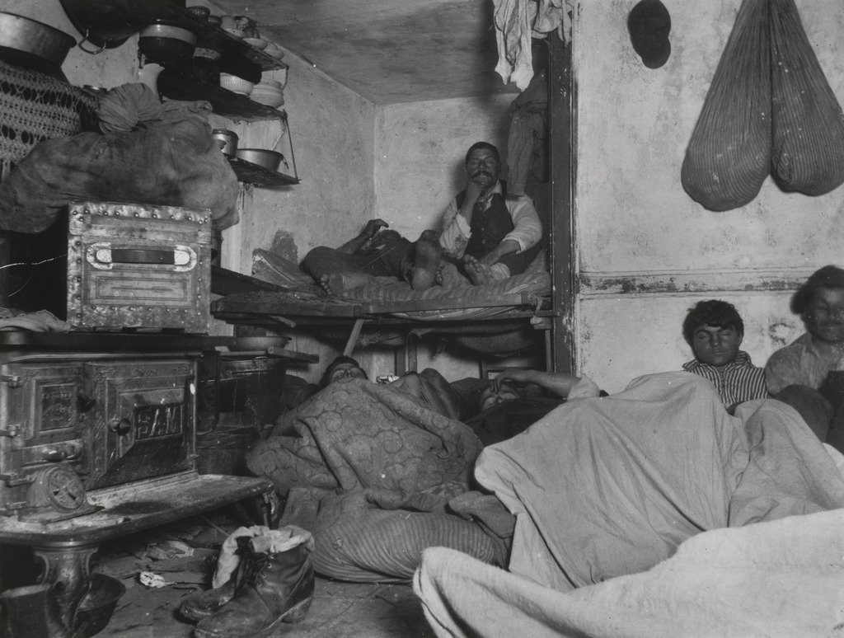
Lodgers in Bayard Street Tenement, Five cents a Spot(1889)

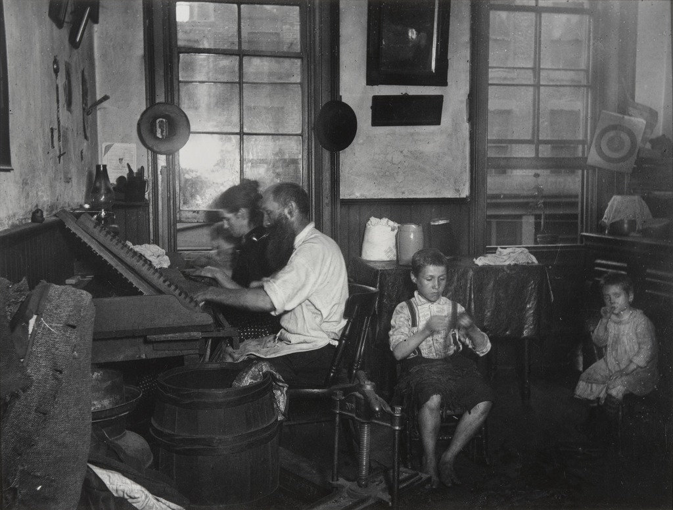
Bohemian Cigarmakers at Work in Their tenement (1889)
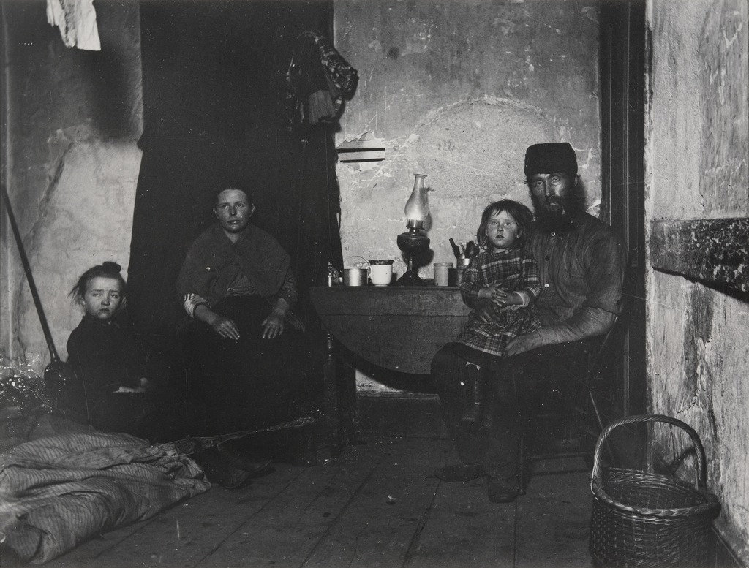
Poverty Gap, West 28th Street. (1889)
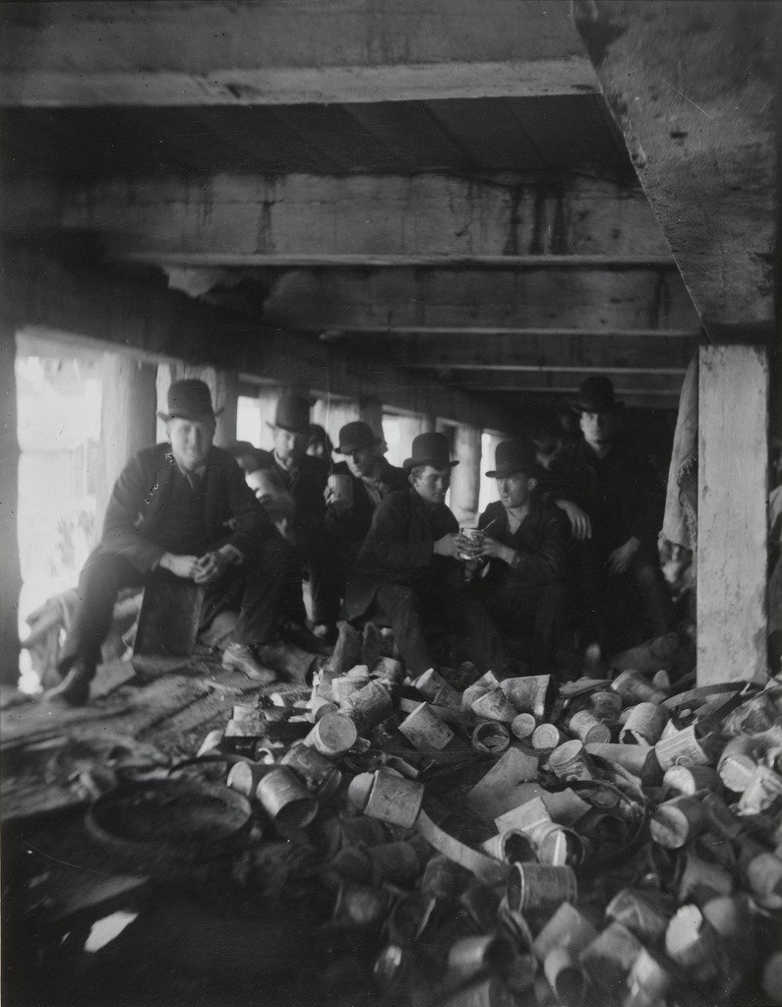
The Short Tail Gang. (1889)
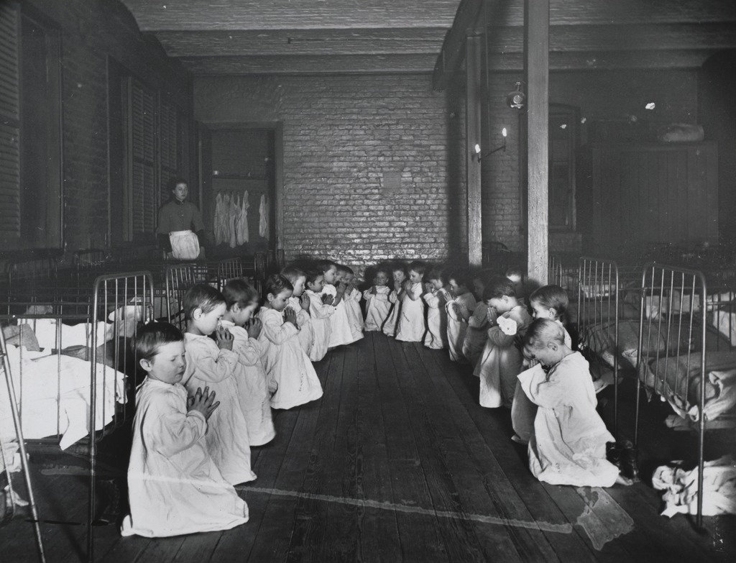
Prayer Time in the Nursery (1889)

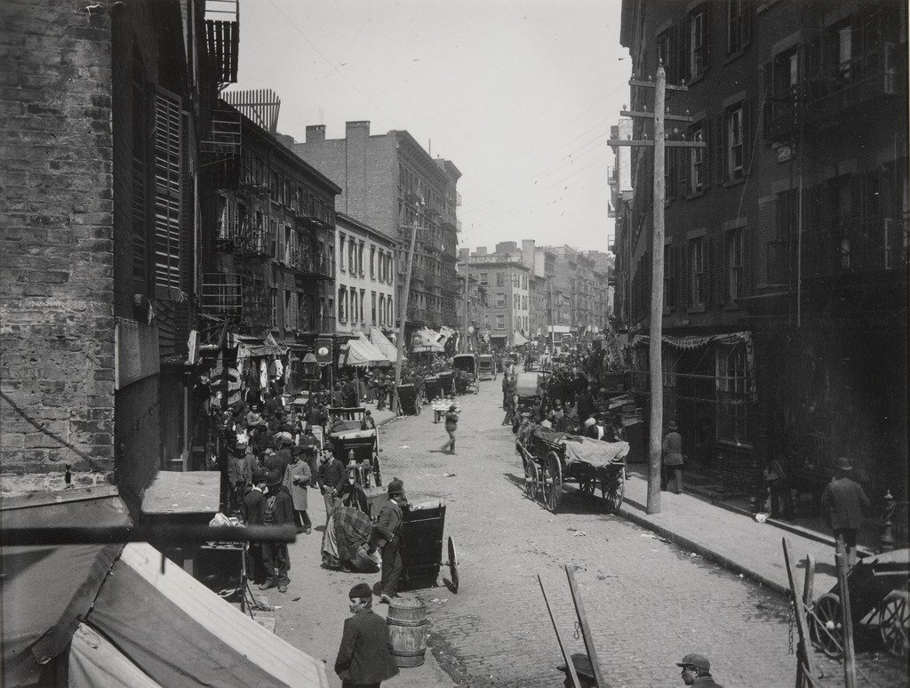
The Bend (1889)
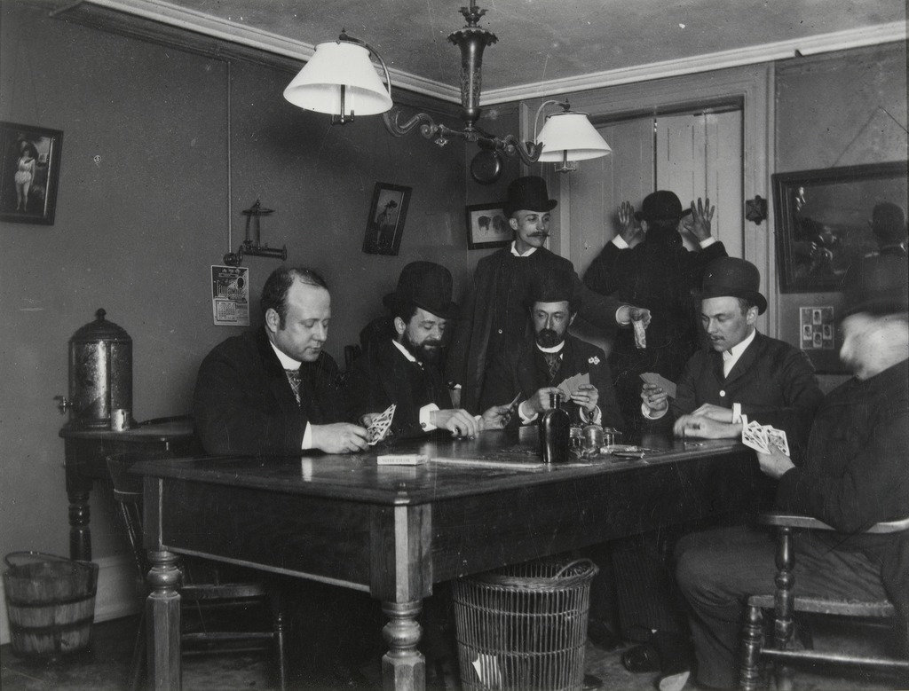
The Reporter’s Office. (1888)
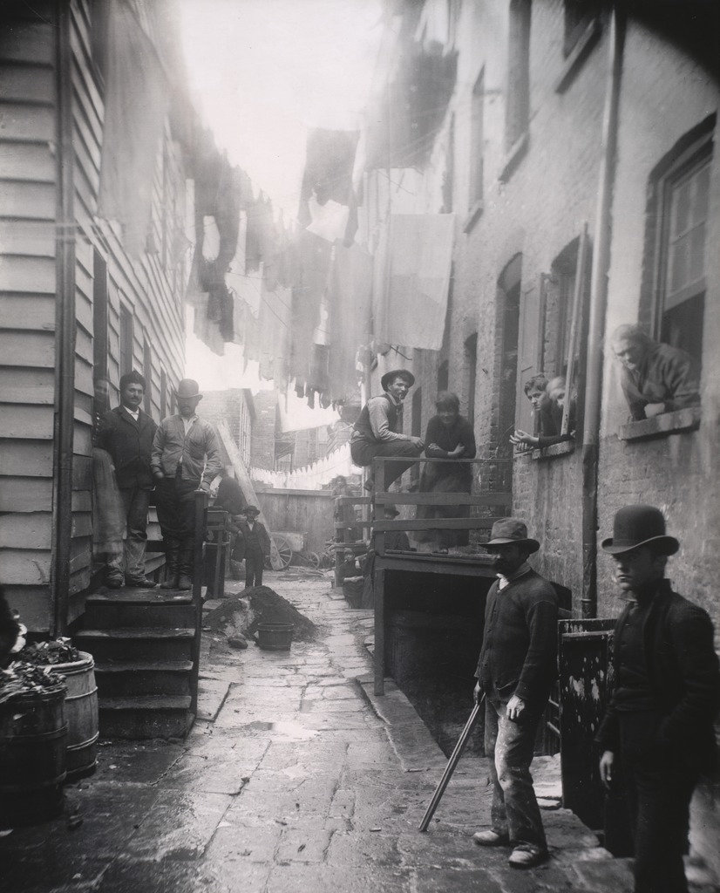
Bandit’s Roost. (1888)
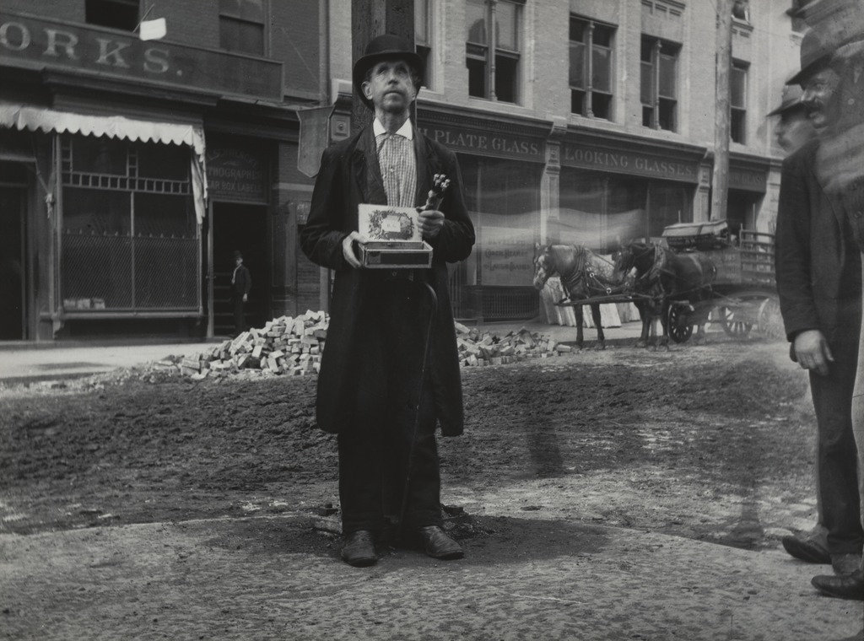
Blind Beggar. (1888)
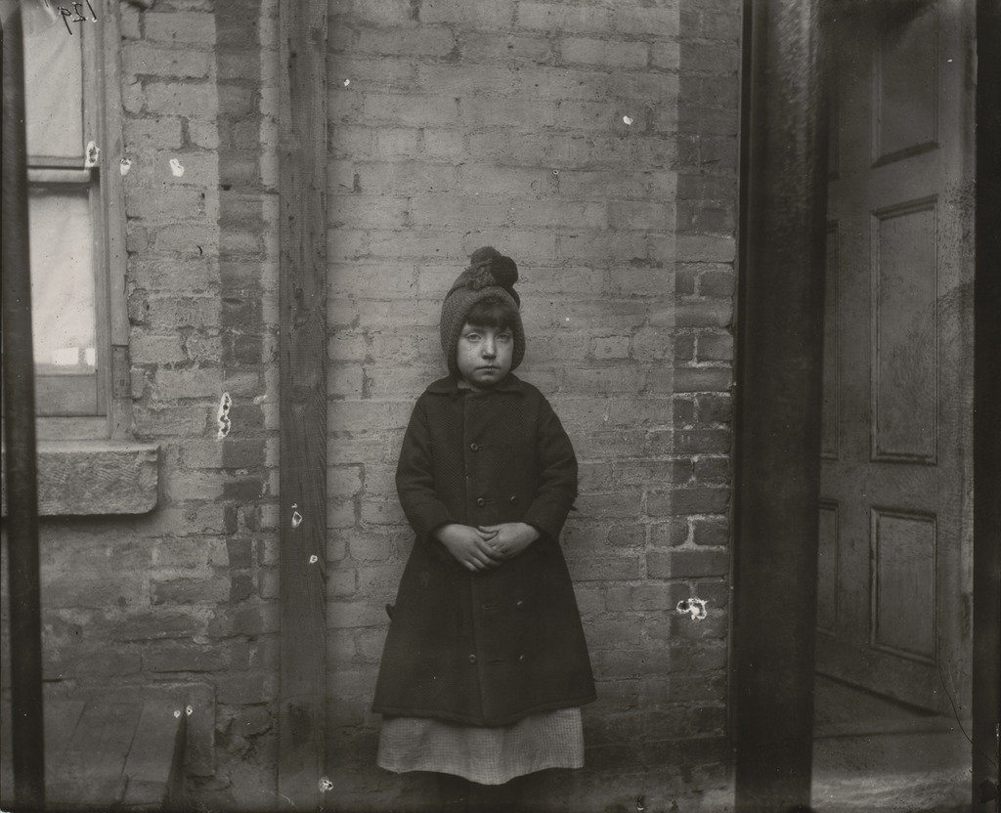
“I Scrubs” – Katie, Who Keeps House. (1890)

