Senior English
Nicolia

Turn it in Instructions

- Go to: turnitin.com
- Either create an account OR login with your current account
- Enroll Nicolia’s English Class
- CLASS ID: _______________-------ENROLLMENT PASSWORD: Nicolia

To Submit a Paper:
- Click on the Class Name
- Locate the Assignment: INDY READ: ROUND 1 NONFICTION
- Click “Submit”

- Make sure you are submitting a “Single File Upload”
  - You should see this:

- If it says:

  - Click on the dropdown arrow and select “Single File Upload”

- Then, Enter in a Submission Title
  - This can be anything that identifies the assignment

- Next, Select where you are submitting your paper from: Google Drive or Your Computer Files.

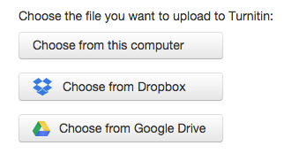

- Once you have select the assignment, Click “Upload”
- Last Step: Confirm the upload was complete.
- You’re done. Logout.

